**Deployment Diagram**

Deployment diagrams depict the physical resources in a system including nodes, components, and connections.

**Basic Deployment Diagram Symbols and Notations**

**Component**

A node is a physical resource that executes code components.  
[Learn how to resize grouped objects like nodes.](http://www.smartdraw.com/resources/tutorials/Objects)

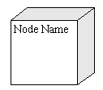

**Association**

Association refers to a physical connection between nodes, such as Ethernet.  
[Learn how to connect two nodes.](http://www.smartdraw.com/resources/tutorials/Lines)

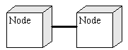

**Components and Nodes**

Place components inside the node that deploys them.

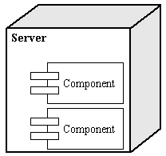

**DEPLOYMENT DIAGRAM:**

